**OVO AUTMOBILES INFO**

(<http://127.0.0.1:5000/>)  **OUR HOMEPAGE**

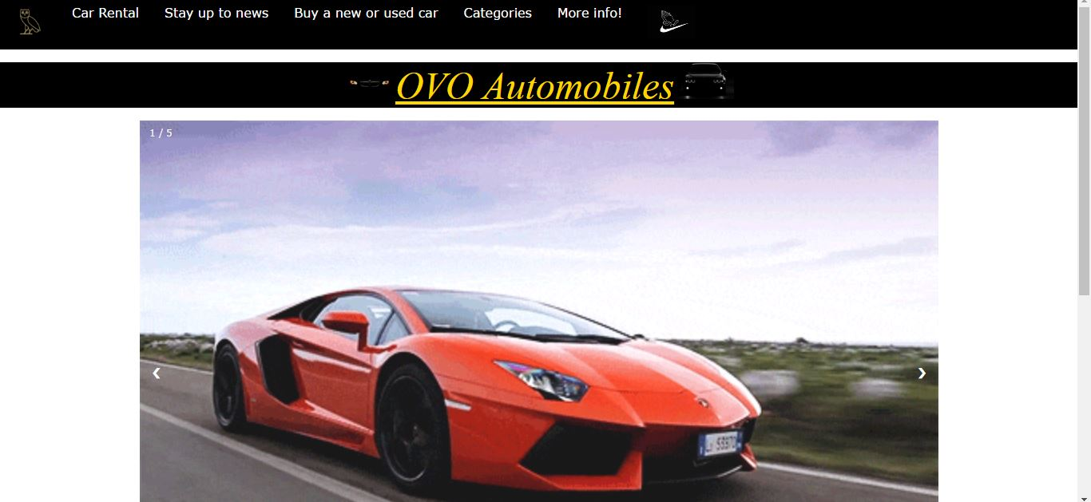

(<http://127.0.0.1:5000/production/1>) **FURTHER INTO OUR PRODUCTION PAGE**

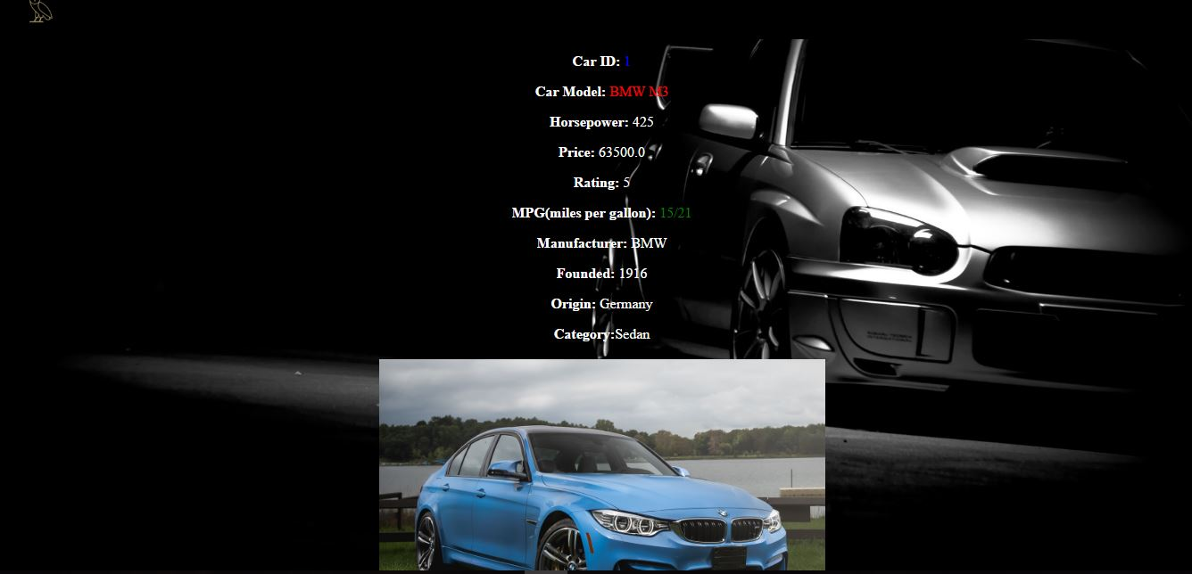

(<http://127.0.0.1:5000/category/1>) **Displays categories**

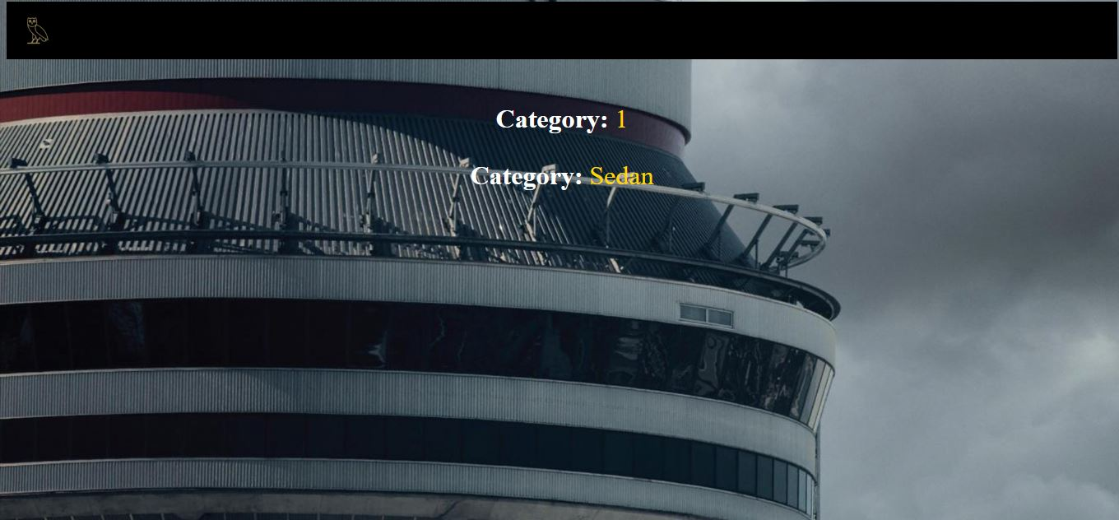

(<http://127.0.0.1:5000/product-search?horsepower=4>) Example of search display

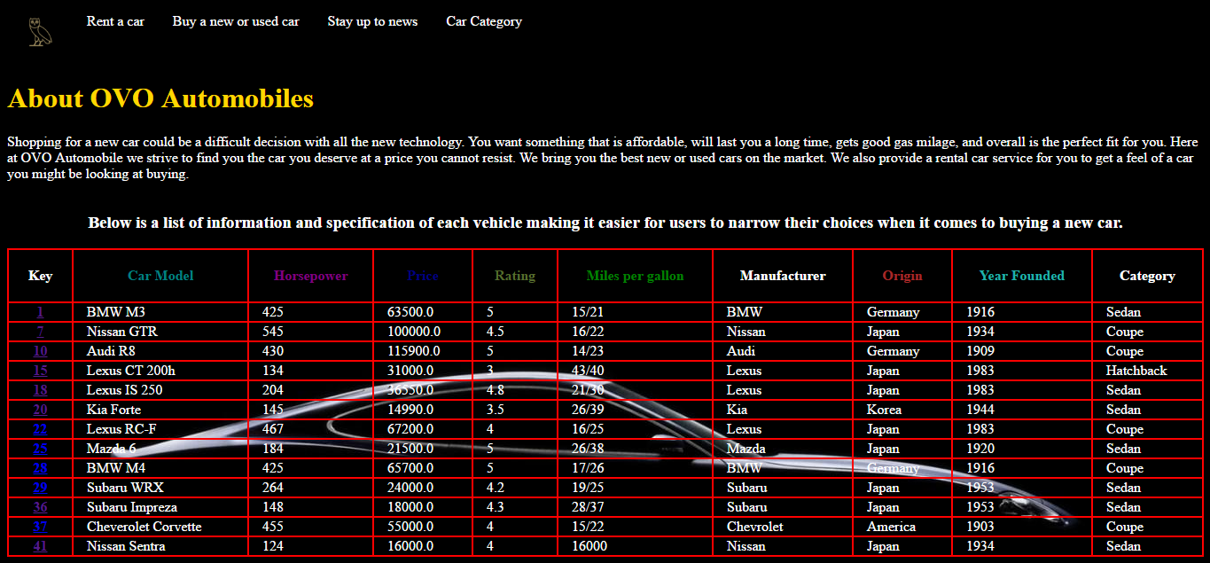

(<http://127.0.0.1:5000/OVOabout>) **Contact Page**

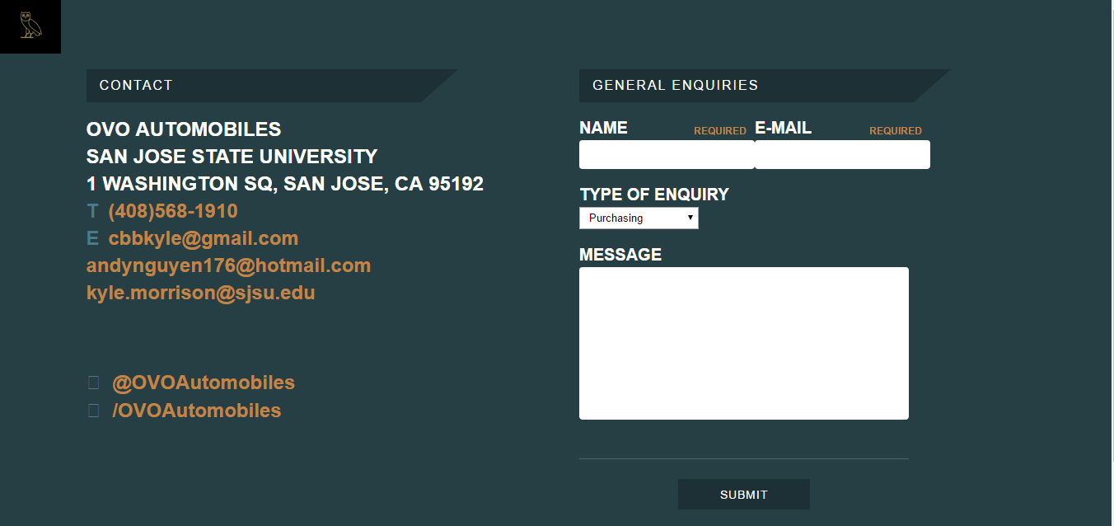

10 Search Functionality Links

* <http://127.0.0.1:5000/production/1>
* <http://127.0.0.1:5000/production/2>
* <http://127.0.0.1:5000/production/20>
* <http://127.0.0.1:5000/category/2>
* <http://127.0.0.1:5000/category/4>
* <http://127.0.0.1:5000/product-search?horsepower=4>
* <http://127.0.0.1:5000/product-search?rating=4>
* <http://127.0.0.1:5000/product-search?origin=Jap>
* <http://127.0.0.1:5000/product-search?manufacturer=Ma>